Nature Scavenger Hunt
Look for these plants and animals in your yard or neighborhood!
Check the boxes for each plant and animal you find!

Trees and Flowers:

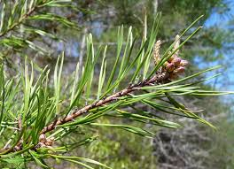 Virginia Pine-Look for spiky green needles.

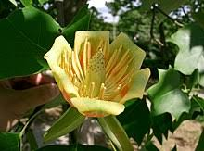 Tulip Poplar- Look for these peach flowers.

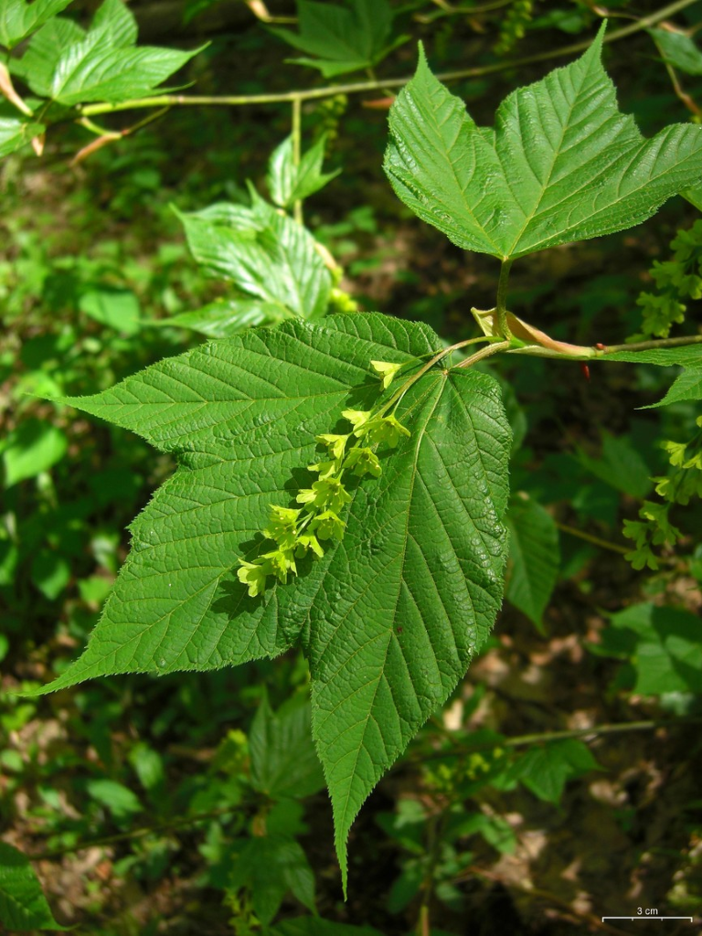 Striped Maple-Look for large three-pointed leaves.

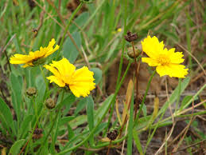 Lanceleaf Coreopsis-Look for tall stems
with bright yellow flowers.

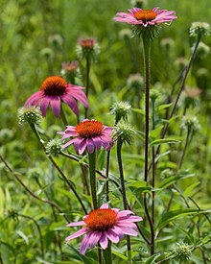 Eastern Purple Cornflower-Look for large,
open purple flowers.

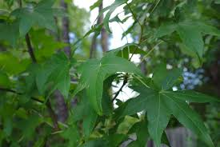 Sweet Gum Tree-Look for five-pointed
leaves.

Animals:

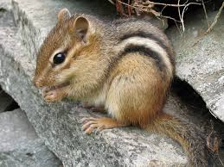 Eastern Chipmunk-Look for his striped
back.

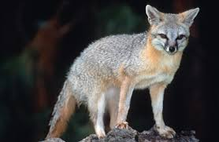 Gray Fox-Look for his soft silver fur.

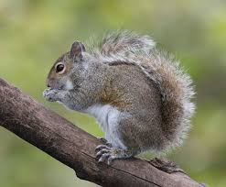 Eastern Gray Squirrel-Look for his long
bushy tail.

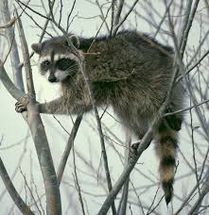 Raccoon-Look for his face mask and ringed tail.

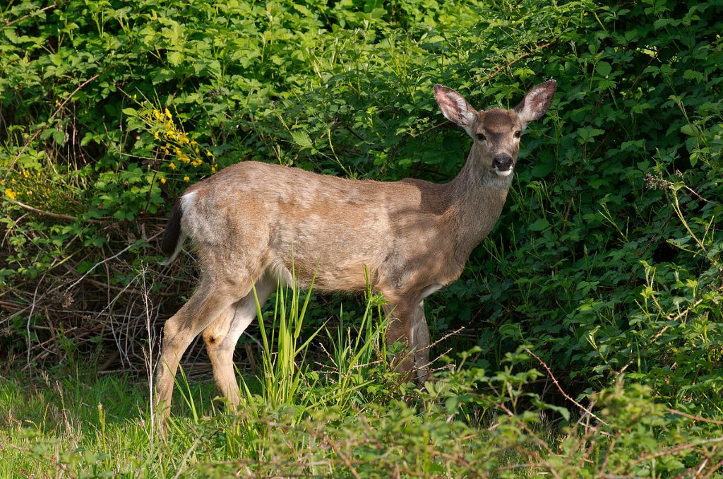 White Tailed Deer-Look for her
white tail.

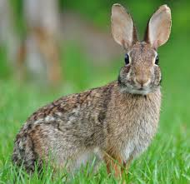 Eastern Cottontail-Look for his tall ears
and white tail.

